TESTIMONY
BEFORE THE LEGISLATURE OF THE VIRGIN ISLANDS
Committee on Government Operations, Veterans Affairs, and Consumer Protection.
May 7, 2026

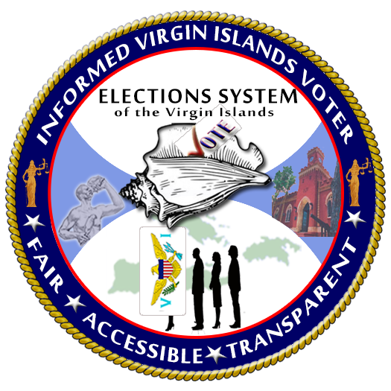
BILL NO. 36-0187
CAROLINE F. FAWKES
SUPERVISOR OF ELECTIONS
ELECTION SYSTEM OF THE VIRGIN ISLANDS

