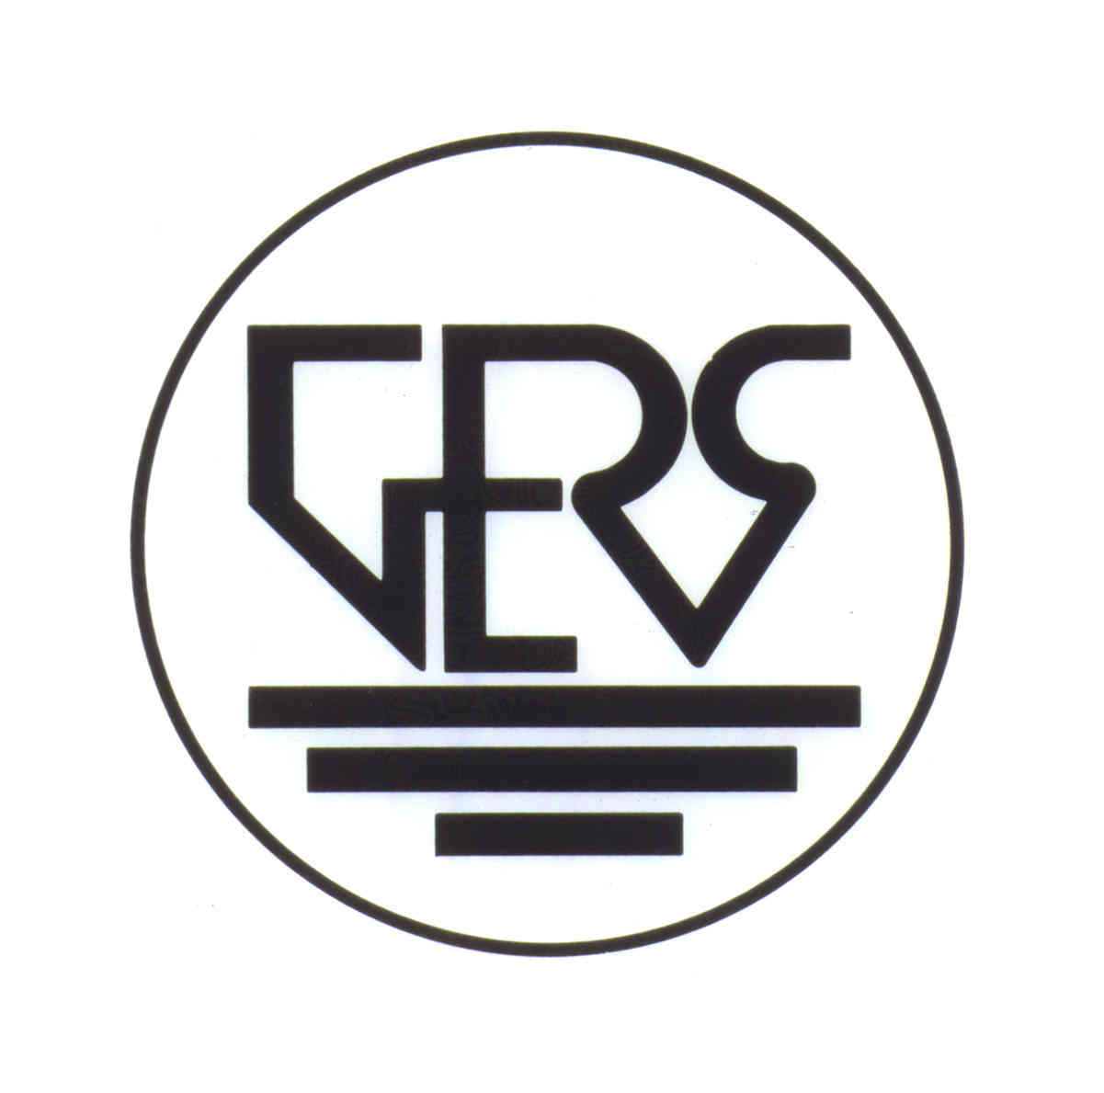

THE GOVERNMENT EMPLOYEES’ RETIREMENT SYSTEM OF THE VIRGIN ISLANDS

PRESENTATION
TO
THE COMMITTEE ON GOVERNMENT OPERATIONS, VETERAN AFFAIRS AND CONSUMER PROTECTION
OF
THE THIRTY-SIXTH LEGISLATURE
OF
THE VIRGIN ISLANDS OF THE UNITED STATES

Bill No. 36-0066

An act amending Title 29 of the Virgin Islands Code, Chapter 15 by adding a Section 928a providing that all officials and employees of the Virgin Islands Public Finance Authority and its wholly owned subsidiaries must be members of the Government Employees’ Retirement System of the Virgin Islands.

The Earle B. Ottley Legislative Hall
St. Thomas, U.S. Virgin Islands
May 20, 2025
9:00 AM
Good morning, Honorable Avery L Lewis, Chairperson of the Committee on Government Operations, Veterans Affairs, and Consumer Protection, Committee Members, other distinguished Senators in the chambers, and the listening and viewing audience. I am Ishmael A. Meyers, Jr, General Counsel of the Government Employees' Retirement System of the Virgin Islands ("GERS").
The GERS appreciates this opportunity to give testimony on Bill No. 36-0066, an act to amend Title 29 of the Virgin Islands Code, Chapter 15 by adding a Section 928a to provide that all officials and employees of the Virgin Islands Public Finance Authority ("PFA") and its wholly owned subsidiaries must be members of the GERS.
The GERS was created on October 1, 1959 as a retirement and benefit system for officials and employees of the Government of the United States Virgin Islands and their dependents and beneficiaries, for the payment of retirement annuities, disability annuities, and other benefits as provided in the Virgin islands Code to said officials and employees, and to their dependents and beneficiaries, after stated periods of service and upon fulfillment of certain conditions set forth in the Virgin Islands Code.
Title 3, Section 702 of the Virgin Islands Code defines "Government" as the Government of the United States Virgin Islands and its agencies and instrumentalities. Employer is defined as the Government of the United States Virgin Islands and its agencies and instrumentalities, including all autonomous and semiautonomous agencies of the Government of the Virgin Islands.
The PFA is a body corporate and politic, constituting a public corporation and autonomous instrumentality, per Title 29, Section 918 of the Virgin Islands Code . As such, all current employees of the PFA are members of the System. The System currently receives employer and employee contributions for all employees of the PFA. However, the System does not currently receive any contributions from any of the entities owned by the PFA. For this reason, the GERS wholeheartedly supports the spirit of this Bill.
Although the System experienced an unprecedented double-digit return on its investment of 24.3% last year, it is still in a precarious financial situation. Any additional employee and employer contributions will assist in shoring up the system's finances.
Act No. 5826 of 1993, which created a legislative avenue for the Government of the Virgin Islands to purchase WICO, clearly states in Section 8 that WICO "shall be deemed to be a public entity operating on behalf of the Government of the Virgin Islands rather than a private corporation”. However, since the PFA purchased WICO in 1993, the agency has maintained that it is a private entity owned by a government agency and as such, not subject to membership in the GERS. Nevertheless, courts have been chipping away at their private entity claim. In Sprauve v. West Indian Co., 799 F.3d 226 (3rd Cir. 2015), the Third Circuit held "because WICO was established as a government corporation pursuant to a special act of the Virgin Islands Legislature to further government objectives, and WICO is permanently and completely controlled by government appointees, it is part of the government for the purposes of a constitutional and 1983 claim". In V.I. Taxi Association v. WICO, 66 V.I. 473 (V.I. 2017), the Supreme Court of the Virgin Islands stated that Act 5826 classifies WICO as a public corporation, and therefore, their claim about being a government agency only for the purpose of taxation was false. So, in the view of the Virgin Islands Supreme Court, WICO is a public corporation and not private, which is what Section 8 of Act 5826 clearly states.
The creation of Virgin Islands Next Generation Network ("viNGN") is not quite as clear as that of WICO, and the agency lacks judicial scrutiny. Notwithstanding its history, viNGN is a public corporation and a wholly owned subsidiary of the PFA. Therefore, the System firmly agrees that the employees of viNGN should be members of the System, by virtue of viNGN’s status as a public corporation, wholly owned by the PFA.
As stated earlier, the GERS supports this bill, but we recommend the following changes. First, the bill states that the contributions shall be paid semi-annually. The system believes that the contributions should be paid in the same manner as prescribed by law for Government instrumentalities and agencies. Second, the statute should apply to new employees hired on or after the date of the statute's enactment with an option to join for senior employees. .
This concludes my testimony. Thank you for allowing the GERS to participate in this hearing. I am available to answer any questions related to the topic.

