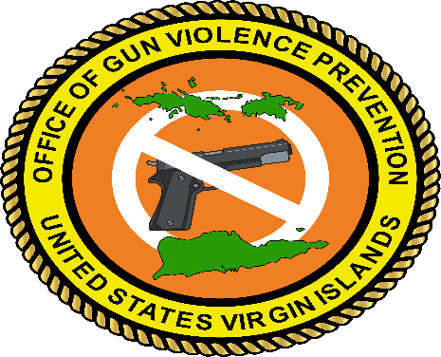

June 9, 2025

Senate Testimony for Bill No. 36-0090: An act amending title 1 Virgin Islands Code, chapter 11 by adding section 200m to declare the week beginning the Monday before the first Friday in June as the Virgin Islands Gun Violence Awareness Week. Proposed by Senator Angel L. Bolques, Jr.

Prepared by: Antonio Emanuel, Executive Director Office of Gun Violence Prevention

Greetings members of the 36th Legislature. I am Antonio Emanuel, the Executive Director of the Governor’s Office of Gun Violence Prevention. I am honored to have been invited to give testimony in support of Bill No. 36-0090: An act amending title 1 Virgin Islands Code, chapter 11 by adding section 200m to declare the week beginning the Monday before the first Friday in June as the Virgin Islands Gun Violence Awareness Week. Proposed by Senator Angel L. Bolques, Jr.
Gun Violence Awareness Month and Gun Violence Awareness Day was founded in 2015 to honor Hadiya Pendleton, a 15-year-old girl from Chicago who was shot and killed on a playground just one week after performing at President Obama’s second inauguration in 2013.
This year 2025, National Gun Violence Awareness Day fell on June 6, the first Friday of the month. Although a National Gun Violence Prevention Week has not been established members of communities across the country were asked to wear orange with us on June 6-8, 2025, in solidarity to honor victims and survivors and help support communities working to end gun violence.
Like ours other communities across the country are plagued with senseless gun violence. In response to the violence in the territory in 2019 the legislature approved Bill 33-0126 formulating the Office of Gun Violence Prevention and in 2022 the Office of Gun Violence Prevention was opened under the Governor’s Office.
During the month of June many government agencies, non-profit organizations and community stakeholders use that time to have events such as forums, town halls, vigils and conferences that bring attention to community violence and engage residents to discuss strategies, initiatives and appropriate responses to help prevent violence and make available resources to assist those affected by community violence.
The Office of Gun Violence Prevention does not wait for a designated day, week, or month to be active or engage our community. Throughout the year we constantly host, participate, collaborate, or sponsor community events and activities that focus on violence prevention. Partnering with other agencies and organizations helps broaden our reach for delivery of service to our community residents.
Having a designated week will help government agencies, community organizations and other community stakeholders focus on creating during that time affective outreach, public service announcements, educational programs, activities, or events that deter violence, assist victims of violence, and bring communities together.
Thank you for allowing me to offer testimony in full support of Bill 36-0090 declaring the week beginning the Monday before the first Friday in June as the Virgin Islands Gun Violence Awareness Week.

