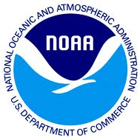
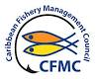
CARIBBEAN FISHERY MANAGEMENT COUNCIL,
270 MUÑOZ RIVERA AVENUE, SUITE 401
SAN JUAN, PUERTO RICO 00918-1903
(787) 766-5926 – www.caribbeanfmc.com
______________________________________________________________________________

TESTIMONY BEFORE THE COMMITTEE ON ECONOMIC DEVELOPMENT AND AGRICULTURE, 36TH LEGISLATURE OF THE US VIRGIN ISLANDS, NOVEMBER 10, 2025
The CFMC testimony and supportive documents for the requested topics:
• Overview of the Caribbean Fishery Management Council’s current initiatives affecting the U.S. Virgin Islands.
- The CFMC prepares fishery management plans submitted to the Secretary of Commerce (Secretary) via NOAA Fisheries for review and approval. If approved, the plans are implemented in the Exclusive Economic Zone (which, in the case of the USVI, covers the area three miles from shore to the limit of the 200-mile fishing area of the USA). If the local governments, in this case, the USVI Government, consider appropriate, compatible regulations are promulgated and enforced by local authorities in coordination with the NOAA Fisheries Office of Law Enforcement (OLE).
Presently, the CFMC is developing and submitting amendments to the Island-Based FMPs to benefit US Caribbean fisheries.

In addition these plans are going to be review to implement Presidential E.O. 14276 which calls for, among others, “ (i) … that each Regional Fishery Management Council, within 180 days of the date of this order, provide the Secretary of Commerce with updates to their recommendations submitted pursuant to Executive Order 13921, to reduce burdens on domestic fishing and to increase production. Building upon the earlier goals, identified actions should stabilize markets, improve access, enhance economic profitability, and prevent closures. The Regional Fishery Management Councils will commit to a work plan and a schedule for implementation to ensure these actions are prioritized.” (See Attachment 1, which has the EO 14276 detailing the purpose and policy.)

The first step to comply with this order has been accomplished by submitting a document requested by NOAA Fisheries detailing actions the CFMC will take during the following years to amend the fishery management plan accordingly, once the Secretary approves these proposed actions.
• Updates on island-based fishery management plans and their implementation status.
The CFMC changed from species-based fishery management (originally 4 FMPs, one each for spiny lobster, queen conch, reef fish and corals) for the US Caribbean to an Island-based approach in response to requests from stakeholders, especially fishers, commercial fishers, who participated in the discussions voicing the differences among Islands that led to the separate fishery plans. The Comprehensive Fishery Management Plan for the St. Thomas/St. John Exclusive Economic Zone (https://caribbeanfmc.com/images/pdf/carib_fmp_st_thomasst_john.pdf )
and the Comprehensive Fishery Management Plan for the St. Croix Exclusive Economic Zone (https://caribbeanfmc.com/images/pdf/carib_fmp_st_croix.pdf)
were finalized in December 2019 and implemented in October 13, 2022 (https://www.govinfo.gov/content/pkg/FR-2022-09-13/pdf/2022-19409.pdf ).
These FMPs and the management measures within them, following the MSA guidance for the development of FMPs, are implemented in the Exclusive Economic Zone (EEZ) that in the USVI extends from the 3 nm from shore boundary to the 200 nm offshore boundary for each District. Management measures within each FMP apply to the EEZ of each Island.
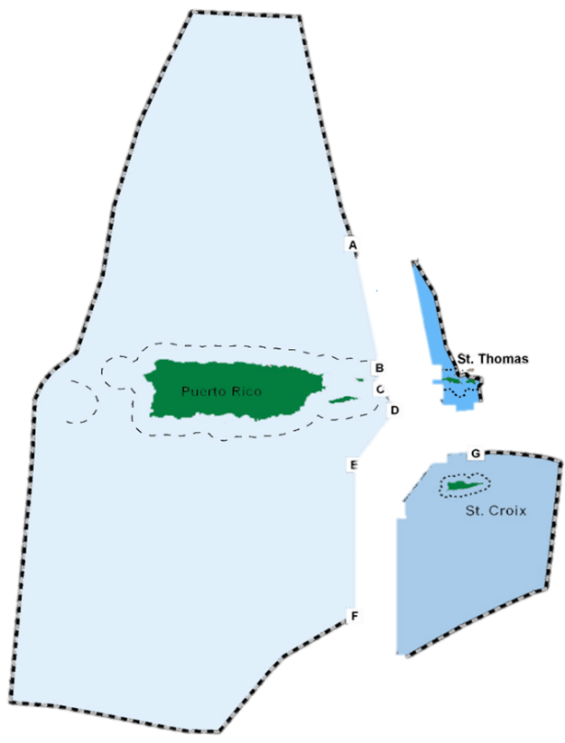
Among the reason for the development of Island-based FMPs; one each for the Districts of St. Thomas/St. John, St. Croix, and Puerto Rico were the differences in markets, in targeted species, in compliance with the regulations, and in the compilation of landings data, among others. These idiosyncrasies of cultural and socio-economic differences were included in the development of the plans with tremendous and valuable input from the fishers and other stakeholders with interests in the conservation, management and sustainability of the local fisheries.
These FMPs do have the following regulations in place that are compatible among all 3 FMPs:
- Spiny lobster minimum size, ban on taking berried lobsters.
- No take of Nassau and Goliath groupers, no take of coral, no take of sea cucumbers and sea urchins, no take of three of the largest parrotfishes.
- Minimum size for queen conch, where its take is allowed, and seasonal closure to protect the reproductive period.
- Minimum size of yellowtail snapper.
- No traps, nets, or other bottom tending gear are allowed with the marine protected areas in the EEZ.
However, there are differences in the seasonal closures of groupers and snappers, management with the marine protected areas (months, species), among others.
The species under management, which are currently under review, include differences in the management including annual catch limits and seasonal closures. The CFMC’s District Advisory Panels are very involved in the determination of species in need of conservation and management.
The IBFMPs have been amended to include the following:
- Generic Framework Amendment to the Fishery Management Plans for Puerto Rico, St. Thomas and St. John, and St. Croix: Modification of Spiny Lobster Management Reference Points Based on SEDAR 57 Stock Assessments, including Environmental Assessment, Regulatory Impact Review, and Regulatory Flexibility Act Analysis. September 2022
(This final rule is effective on April 15, 2023. 88 FR 16194)
https://repository.library.noaa.gov/view/noaa/49328

Purpose and need: The purpose of this framework amendment is to update management reference points for spiny lobster under the Puerto Rico, St. Thomas and St. John, and St. Croix FMPs to account for the SEDAR 57 spiny lobster stock assessments and application of the Council’s ABC Control Rule and to revise the AM trigger for spiny lobster stocks.

The need for this framework amendment is to update management measures for spiny lobster stocks based on best scientific information available to prevent overfishing and achieve OY, consistent with the requirements of the Magnuson-Stevens Act.

- Generic Amendment 1 to the Fishery Management Plans for Puerto Rico, St. Thomas and St. John, and St. Croix: Modification to the Buoy Gear Definition and Use. October 2022.
(This final rule is effective on August 21, 2023. 88 FR 46692)
https://repository.library.noaa.gov/view/noaa/51715.

Purpose and need: The purpose of this amendment is to modify the definition of buoy gear included in federal regulations at 50 CFR 622.2 to allow for the use of a greater number of hooks with this gear type when fishing commercially for deep-water snappers and groupers managed under the Puerto Rico FMP, the St. Thomas and St. John FMP, and the St. Croix FMP, and to limit the use of the buoy gear to those fishing commercially.

The need for this amendment is to ensure that commercial fishermen fishing for deep-water snappers and groupers in federal waters off Puerto Rico, St. Thomas and St. John, and St. Croix, can use buoy gear with more than 10 hooks preferred by some fishermen, while protecting the deep-water reef fish resource and its habitat and minimizing user conflicts.

- Environmental Assessment for Framework Amendment 2 to the Puerto Rico, St. Croix, and St. Thomas and St. John Fishery Management Plans: Updates to the Spiny Lobster Overfishing Limit, Acceptable Biological Catch, and Annual Catch Limit. The updates are based on results from the 2022 Update Assessment to the 2019 Southeast Data, Assessment, and Review 57 Stock Assessments for spiny lobster in Puerto Rico, St. Croix, and St. Thomas and St. John. (This final rule is effective on May 30, 2024. 89 FR 34168)
https://repository.library.noaa.gov/view/noaa/66837

Purpose and need: The purpose of Framework Amendment 2 is to update OFLs, ABCs, and ACLs for spiny lobster under the Puerto Rico, St. Croix, and St. Thomas/St. John FMPs to account for the 2022 Update Assessment to the 2019 SEDAR 57 stock assessments.

The need for Framework Amendment 2 is to update management measures for spiny lobster stocks based on best scientific information available to prevent overfishing and achieve optimum yield, consistent with the requirements of the Magnuson-Stevens Fishery Management and Conservation Act.

- Amendment 2 to the Fishery Management Plans for Puerto Rico, St. Croix, and St. Thomas and St. John: Trawl, Net Gear, and Descending Devices.
(This final rule is effective on November 3, 2025. 90 FR 47982)
https://repository.library.noaa.gov/view/noaa/66551
However, the requirement for descending devices is not effective until April 1 2026 https://drive.google.com/drive/u/0/folders/1gD-_szfqbKYZ-X8wGsOBDTdccifyxdW4

Purpose and need: The purpose of this amendment is to prevent potential damage to habitats, including EFH, from certain gear types, protect species associated with such habitats, as well as to promote best fishing practices, and enhance the survival of released reef fish in the EEZ around Puerto Rico, St. Croix, and St. Thomas/St. John.

The need for this amendment is to minimize potentially adverse effects of fishing to habitats and associated species, and to minimize the mortality of bycatch species.

- Amendment 3 to the Puerto Rico, St. Croix, and St. Thomas and St. John Fishery Management Plans: Management Measures for Dolphin and Wahoo.
(This final rule is effective on July 25, 2025. 90 FR 26934)
https://repository.library.noaa.gov/view/noaa/66552

Purpose and need: The purpose of this amendment is to establish size limits and recreational bag limits for dolphinfish and wahoo under the Puerto Rico FMP, the St. Croix FMP, and the St. Thomas/St. John FMP.

The need for this amendment is to develop conservation and management measures for dolphinfish and wahoo stocks in Puerto Rico and the USVI to ensure undersized individuals have adequate time to mature and reproduce, and to take a precautionary approach to management to protect against overfishing for resources with limited management structure.

- Framework Action 3 under the Puerto Rico Fishery Management Plan: Modification of Status Determination Criteria and Management Reference Points for the Triggerfish Stock Complex based on SEDAR 80 Queen Triggerfish Stock Assessment. July 2024.
(This final rule is effective on July 25, 2025. 90 FR 26940)
https://repository.library.noaa.gov/view/noaa/70911

Purpose and need: The purpose of this framework action is to update management reference points for the Triggerfish stock complex under the Puerto Rico FMP to account for the SEDAR 80 Puerto Rico Queen Triggerfish Stock Assessment and application of the Council’s ABC Control Rule.

The need for this action is to update management measures for the Puerto Rico Triggerfish stock complex based on the best scientific information available to prevent overfishing and achieve OY, consistent with the requirements of the Magnuson-Stevens Fishery Conservation and Management Act.

- Environmental Assessment for Framework Action 3 under the St. Croix and St. Thomas, and St. John Fishery Management Plans: Modification of Status Determination Criteria and Management Reference Points based on the SEDAR 80 Queen Triggerfish Stock Assessments. March 2025. (This final rule is under development). https://www.fisheries.noaa.gov/s3/2025-03/Framework-Action-3-USVI-Queen-Triggerfish_03.13.2025.pdf

Purpose and need: The purpose of this framework action is to update management reference points for the queen triggerfish stocks under the St. Croix FMP and St. Thomas/St. John FMP to account for the SEDAR 80 stock assessments and application of the Council’s ABC control rule.

The need for this action is to update management measures for the St. Croix and St. Thomas/St. John Queen triggerfish stocks based on the best scientific information available to prevent overfishing and achieve OY, consistent with the requirements of the Magnuson-Stevens Fishery Conservation and Management Act.

- Amendment 4 to the Puerto Rico Fishery Management Plan: Reclassification of the Rainbow Runner as a Pelagic Fish, including a Fishery Impact Statement, Regulatory Impact Review, and Regulatory Flexibility Act Analysis. June 2025. (This final rule is under development). https://www.fisheries.noaa.gov/s3/2025-06/Final_Amendment-4-Rainbow-runner_6.3.2025_508c.pdf
There are working teams working on the following topics for amendments pertaining to the USVI:
- Changes to the pelagic accountability measures
- Alternative methods to assess US Caribbean species (SEDAR 103)
- Spiny Lobster changes to reference points including the ACLs (SEDAR 91) – just reviewed by the SSC
- Changes to reference points in yellowtail snapper (STT) and parrotfish (STX) (SEDAR 84 – to be reviewed by the SSC
• Insights on Council collaboration with local fishers and government agencies.
The CFMC has established three district advisory panels (DAPs) that allow for better focus on the issues and actions needed to address fishery resources and industry in each island area: St. Thomas-St. John, St. Croix, and Puerto Rico. The DAPs have members from the commercial and recreational sectors that advise the CFMC on all matters related to the practical realities of local fisheries. The chairs participate in every council-related meeting, contributing to the necessary discussions to provide advice to the CFMC.
• Strategies for sustainable fisheries and conservation of marine habitats.
The Magnuson-Stevens Act (MSA) requires the inclusion of strategies for sustainable fisheries and conservation of marine habitats in all fishery management plans. Therefore, the CFMC develops all plans with these two goals in mind, and the proposed regulations follow these. The plans include presentation of all biological, economic, cultural, and social considerations for the recommendations to the Secretary. (The management plans can be accessed at the CFMC webpage: https://www.caribbeanfmc.com/)
• Impacts of federal regulations on the Virgin Islands’ commercial
and recreational fishing sectors.
Federal regulations have positive impacts on the USVI commercial and recreational sectors. The plans ensure that once implemented, the fishery will be sustainable and benefit the USVI for present and future generations.
• Grant opportunities and funding mechanisms available to the U.S.
Virgin Islands through the council or NOAA
The CFMC does not have authorization and budget to issue grants; however, it can recommend funding for projects using NOAA funds to benefit the local fisheries.
• Recommendations for improving data collection, enforcement, and
community engagement in fishery management.
Appropriate funding and training of all personnel involved are key to improving data collection. CFMC and NOAA Fisheries continue working with local agencies to achieve this goal. The same holds for enforcement. The agencies responsible for upholding the law need the necessary funds and continued education of officers to effectively impact the fisheries.
Regarding community engagement, we need to continue outreach and education programs and projects to educate the agency officials and the general public on the importance of
managing the natural resources effectively.
Engaging fishers and citizens since the beginning of management actions is paramount for the success of fisheries' sustainability.

