Paul E. Joseph Stadium On-Site Inspection Report
An inspection of the Paul E. Joseph Stadium Sports Complex was conducted by the chairman of the committee of Culture, Youth, Aging and Sports and Parks on July 1–2, 2025, in response to concerns over construction progress, financial management, and the issuance of a subpoena by the committee. The inspection was conducted using the May 31, 2025 Project Progress Report and on-site observations to verify the accuracy of reported completion, review payment justifications, and identify any potential issues related to oversight or project delivery.
Item No. | Description | Reported Completion (%) | Estimated Spent ($) | Period of Completion | See Appendix on Report
8 | Locker Rooms & Showers | 81% | $161,000.0 | 04/01/24 to 05/09/25 | 1
10 | Public Restrooms | 74% | $184,700.0 | 04/01/24 to 05/09/25 | 2
12 | Entry Pavillion | 97% | $131,200.0 | 04/01/24 to 05/09/25 | 3
15 | Party Deck Area | 82% | $110,100.0 | 04/01/24 to 05/09/25 | 4
19 | Dugouts | 97% | $150,000.0 | 04/01/24 to 05/09/25 | 5
20 | Stairways & Common Spaces | 95% | $312,500.0 | 04/01/24 to 05/09/25 | 6
25 | Mechanical | 63% | $60,000.0 | 04/01/24 to 05/09/25 | 7
26 | Electrical | 78% | $855,100.0 | 04/01/24 to 05/09/25 | 8
9 | Plumbing | 91% | $349,275.0 | 04/01/24 to 05/09/25 | 9
21a | Move Surcharge Materials to Field, Grading, Drainage | 60.00% | $168,000.0 | 04/01/24 to 05/09/25 | 10
16 | Elevator | 92.3% | $180,000.0 | 04/01/24 to 01/31/25 | 11
26a | Light Fixtures | 100% | $101,000.0 | 04/01/24 to 01/31/25 | 12
11 | Concession Areas | 50.00% | $37,500.0 | 04/01/24 to 01/31/25 | 13
N/A | Sitewide Observations (Drainage, Safety, Canopy) | N/A | N/A | 04/01/24 to 01/31/25 | 14
11(vi) | Wall, Tile, Floor, Ceiling | N/A | N/A | 04/01/24 to 01/31/25 | Notes
18(v) | Floor Finishes | N/A | N/A | 04/01/24 to 01/31/25 | Notes
1c | Design Changes CO 10 ($94,800) & CO11 ($95,200) | 100% | $190,000.00 | 04/01/2024 to 05/09/2025 | Unexplained Design Changes
1d | Additional Design Costs CO13 | 100% | $612,500.00 | 04/01/2024 to 05/09/2025 | Unexplained Design Changes

Appendix 1 through 13, Descriptions of Findings:
Appendix 1. Locker Rooms & Showers
Inspection Findings:
Upon visual inspection conducted on July 1–2, 2025, the locker rooms and shower areas were observed to be structurally formed but remain materially incomplete. The following critical components were not present at the time of inspection:
- No plumbing fixtures (toilets, sinks, shower heads, or controls) were installed; only wall-mounted pipe stubs were visible.
- No electrical fixtures or systems were present. There were no switches, outlets, light fixtures, or conduit observed.
- No HVAC or ventilation systems were installed or visible within the space.
- Interior finishes had not been applied. The walls and floors remained as unfinished concrete, with no tiling, waterproofing, or partitions in place.
- No functional systems were operational, and the space is currently unusable.
Conclusion:
The reported 81% completion rate is not supported by observable site conditions. Based on the lack of mechanical, electrical, plumbing, and interior finish work, the actual construction progress is estimated to be no greater than 30 to 35 percent. The space is nonfunctional and far from operational readiness. Clarification is required to reconcile the reported progress and expenditure with the physical state of work.
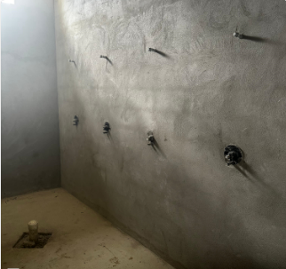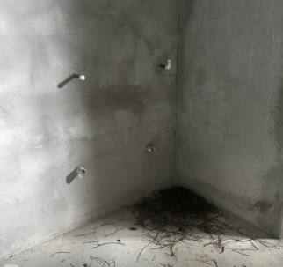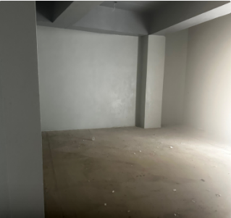
Appendix 2. Public Restrooms
The public restroom areas were found to be in a largely undeveloped state at the time of the July 1–2, 2025 site visit. Conditions observed included:
- Only rough plumbing was present. Pipe stubs were installed, but no toilets, urinals, mirrors, sinks, or flush valves were in place.
- There were no electrical systems visible, including light fixtures, switches, or wiring.
- No interior finishes had been applied. Walls were uncoated masonry, and floors remained bare concrete.
- No partitions or other infrastructure required for occupancy or use were installed.
- No operational systems or utilities were functioning at the time of inspection.
Conclusion:
The reported 74% completion figure is inconsistent with observable site conditions. The space remains non-operational and materially incomplete. Based on visible progress, the actual construction status is estimated to be under 35%. Additional work is required across all mechanical, electrical, and interior finishing disciplines before this space can be considered near completion. Clarification is required to justify both the reported progress and the corresponding expenditure.
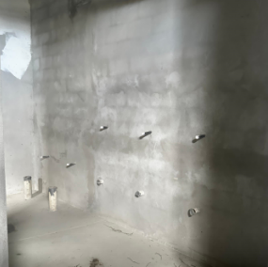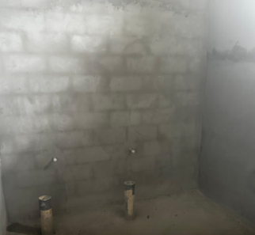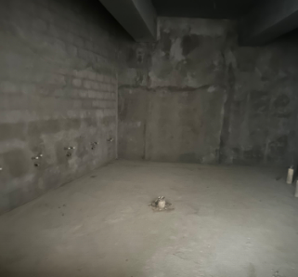

Appendix 3. Entry Pavilion
The exterior of the Entry Pavilion appears painted and roofed; however, the structure remains architecturally and functionally incomplete based on inspection conducted July 1–2, 2025. The following deficiencies were documented:
- Lighting and electrical fixtures were not installed.
- Tilework and interior flooring finishes were not present.
- Doors, windows, and other physical enclosures were missing.
- Security features (locks, doors, railings) and utilities (lighting, power) were not in place.
Additionally, the upper-level areas lacked required safety railings. Construction materials were still present, and several access points remained unsecured at elevated heights, posing a serious safety hazard.
Conclusion:
The Pavilion is not suitable for public or ceremonial use in its current condition. The physical structure lacks critical systems for usability, safety, and code compliance. The reported 97% completion is not supported by on-site conditions and requires formal clarification. Further work is necessary to achieve a usable and compliant facility.
.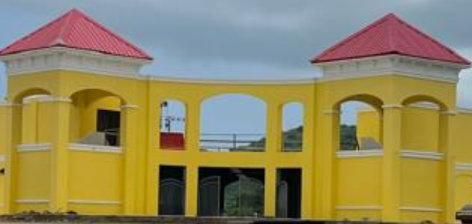 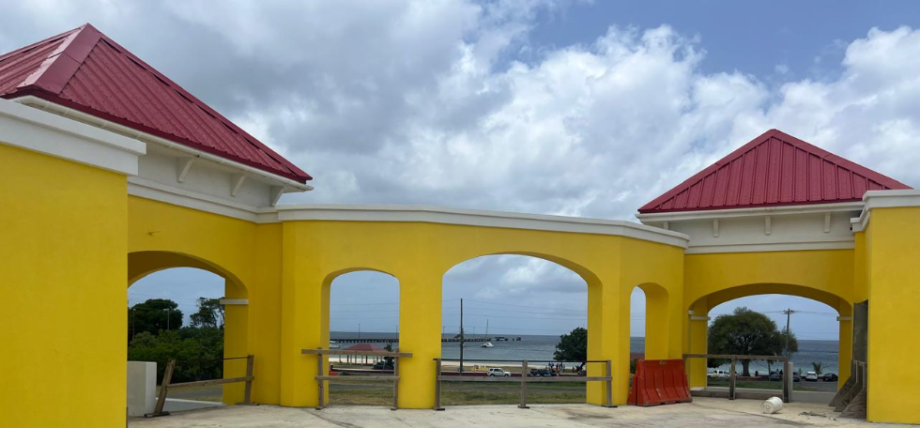

Appendix 4. Party Deck Area
The Party Deck Area consists of an unfinished structural concrete slab, with no visible finish work, coatings, or expansion joints. The surface was incomplete at the edges, surrounded by temporary formwork and construction materials, and lacked any signs of functional integration or readiness for use. The following infrastructure was missing:
- Railings or barriers
- Lighting
- Electrical or plumbing hookups
- Seating, furnishings, or shade structures
There was no functional infrastructure present to support occupancy or event use. The area lacked basic safety features and utility access required for public or private gatherings.
Conclusion:
The reported 82% completion is not supported by the physical condition of the site. The space remains nonfunctional and lacks essential systems for safe and usable operation. Clarification is required to understand how progress was measured against actual deliverables.
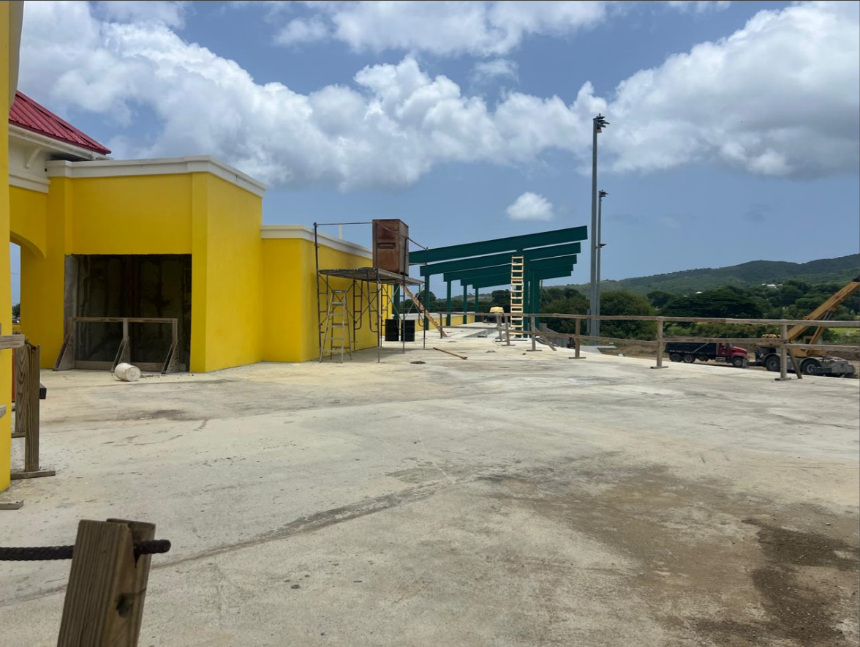

Appendix 5. Dugouts
At the time of inspection on July 1–2, 2025, the dugouts consisted only of completed structural enclosures. The essential functional components required for readiness and use were missing. Specifically, the dugouts lacked:
- Benches or seating
- Backrests
- Protective netting or fencing
- Lighting, electrical conduit, or any visible utility connections
The surrounding area also showed no signs of surface treatments, equipment mounts, or safety installations. Without these components, the dugouts do not meet standard requirements for use by athletic teams or support personnel.
Conclusion:
The reported 97% completion is not supported by the current condition of the space. Based on the absence of fixtures, utilities, and essential safety features, actual completion is estimated to be no greater than 40%. Additional work is required to bring the dugouts to a usable and safe condition that meets field-readiness standards.
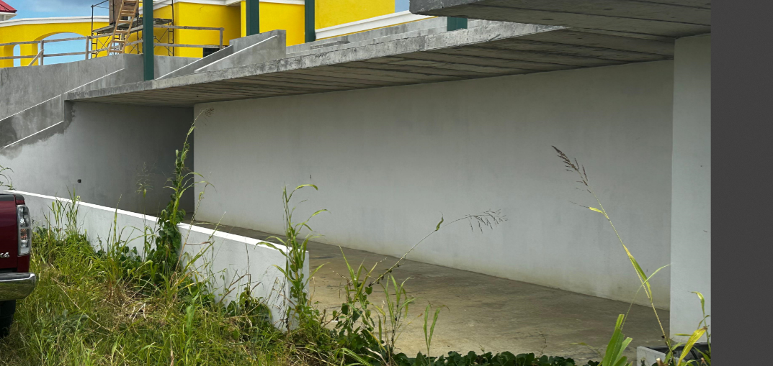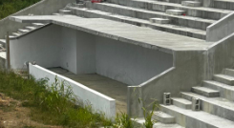

Appendix 6. Stairways & Common Spaces
At the time of inspection on July 1–2, 2025, only two stairways had been constructed. While these appear structurally formed, they remain incomplete. Observed conditions include:
- No handrails or guardrails installed
- No lighting or electrical provisions visible
- No surface finishes applied
- Two additional stairways, as described in planning, were not yet started
The overall appearance suggests the stairs are in a basic formwork stage with minimal detailing. There is no indication of accessibility features, integrated lighting, or specialized structural treatments that would elevate cost. The surrounding areas also lack signs of completed common-space infrastructure (e.g., walkways, lighting, safety barriers).
Conclusion:
The reported 95% completion and $312,500 expenditure appear disproportionate to the current scope of visible work. Based on what was inspected, actual completion is estimated to be below 50%. A detailed cost breakdown is needed to reconcile this line item against observable progress and remaining deliverables.
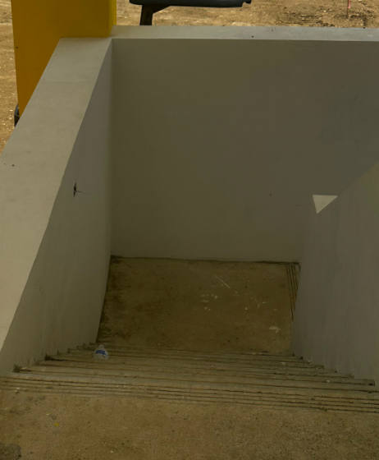

Appendix 7. Mechanical
At the time of inspection on July 1–2, 2025, there were no visible evidence that mechanical systems had been installed or initiated. Specifically:
- No rooftop or interior HVAC units were observed
- No ductwork, ventilation fans, grilles, or air handling components were present
- No openings, wall penetrations, or structural supports for mechanical infrastructure were visible
- No mechanical service rooms or enclosures showed signs of mechanical equipment preparation or construction
In the U.S. Virgin Islands, mechanical ventilation is still required in specific spaces such as restrooms, locker rooms, and enclosed service areas, even when natural ventilation is used elsewhere. The absence of any ventilation or cooling systems in these spaces indicates that mechanical work has likely not started.
Conclusion:
There is no observable progress supporting the reported 63% completion or $60,000 invoiced cost. Based on current site conditions, mechanical system installation appears to be at or near 0%. Clarification is needed to verify what scope was claimed as complete and whether any off-site procurement or staging exists to account for the reported figure.

Appendix 8. Electrical
During the inspection conducted July 1–2, 2025, there were no evidence of functional or near-ready electrical systems in any of the inspected areas. Observations included:
- Electrical panels were installed but remained incomplete, with no breakers, fuses, or internal wiring
- No visible conduit connections were active or terminated
- No lighting, outlets, switches, or distribution systems were present in interior or exterior zones
- Site photos confirm that even basic service installation steps had not been completed
These findings were consistent across all areas, including the field, upper-level structures, restrooms, locker rooms, and service rooms.
Conclusion:
The reported 78% completion and $855,100 expenditure are not supported by the current condition of the electrical infrastructure. The electrical systems remain incomplete and non-functional. Based on the absence of active installations, actual progress appears minimal. Clarification is required to determine how this percentage was calculated and what scope of work, if any, has been completed or procured.
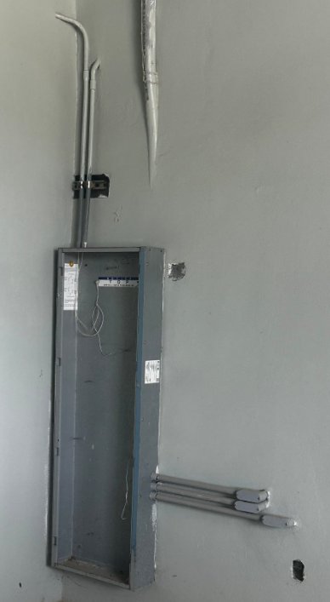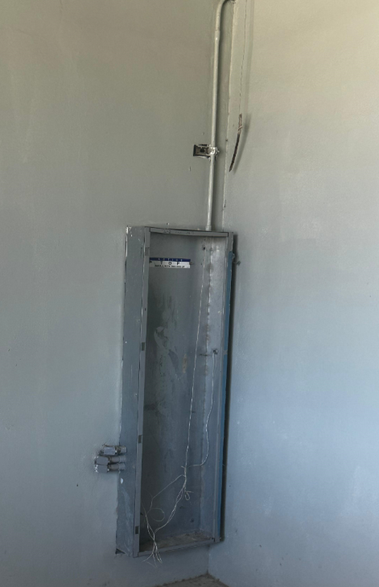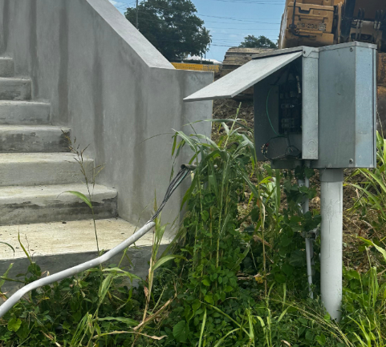

Appendix 9. Plumbing
Plumbing rough-in work was visible throughout the facility during the inspection conducted July 1–2, 2025. Pipe stubs for water supply and drainage had been installed in restrooms, locker rooms, and other utility areas. However:
- No final fixtures (toilets, sinks, urinals, faucets, or shower heads) were installed
- There were no evidence of system testing, labelling, or inspection approvals
- No wall tiling, waterproofing, partitions, or plumbing-related finishes were present
- No visible signs indicated that the plumbing systems were ready for functional use or final inspection
While rough-in progress appeared substantial, essential components for system activation and usability were not yet in place.
Conclusion:
The reported 91% completion overstates the current readiness of the plumbing systems. Based on visual inspection, actual progress is estimated at approximately 65–70%. Final fixture installation, finish work, and system commissioning are still required to reach operational status. Clarification is recommended to align the reported figure with remaining deliverables.
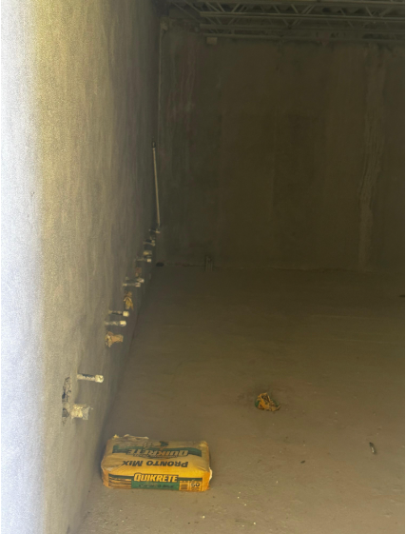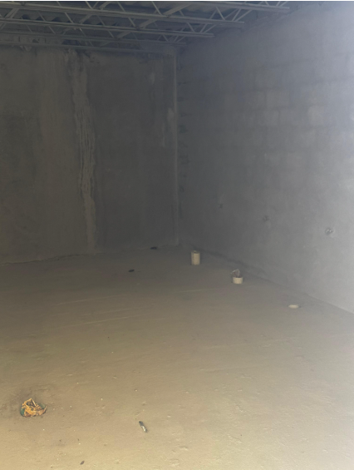

Appendix 10. Move Surcharge Materials to Field, Grading, Drainage
The scope of work for this item includes critical site preparation activities such as soil surcharge placement, contour grading, and installation of a stormwater drainage system. During the July 1–2, 2025 inspection, the following conditions were observed:
- No visible surcharge mounds, compacted fill, or engineered soil preparation were present
- The field remained uneven and ungraded, with no contouring evident
- No grading stakes, boundaries, or slope indicators were identified
- No stormwater infrastructure was observed. There were no catch basins, trenching, drainpipes, or related components visible
- While some equipment was staged near the field, there was no indication of active work or completed phases
Conclusion:
The reported 60% completion is not supported by site conditions. Based on visual inspection, the grading and drainage work does not appear to have meaningfully started. The current condition suggests early staging at best. Clarification is required to determine what percentage of scope has been completed, and whether any off-site fabrication or material delivery contributes to the reported figure.
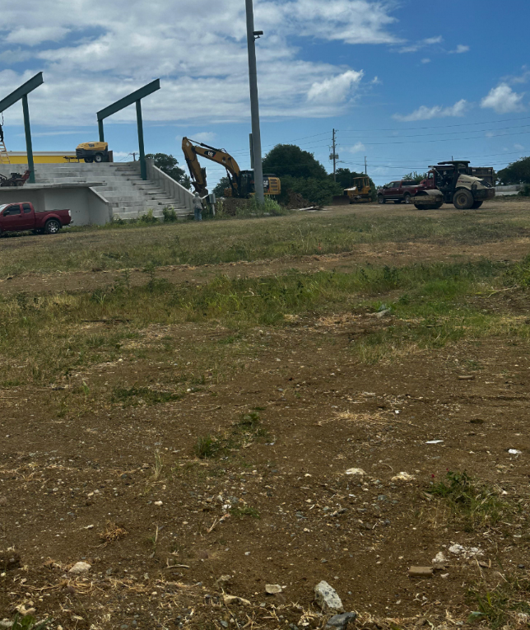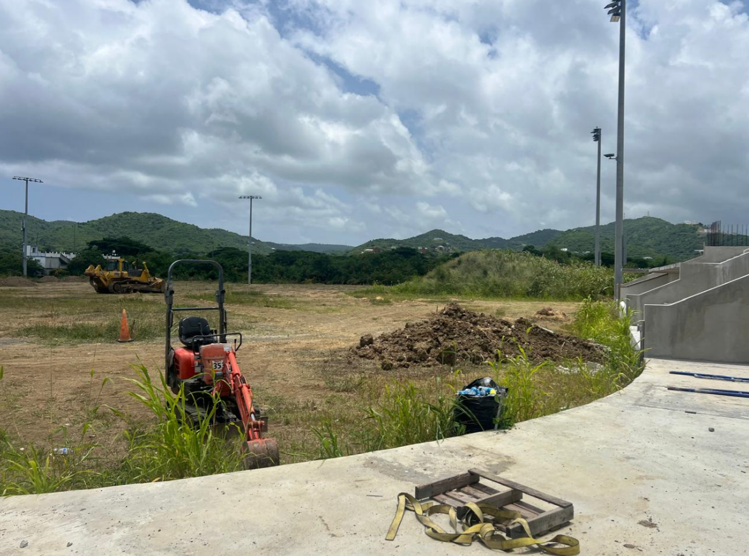
Appendix 11. Elevator
At the time of inspection on July 1–2, 2025, the elevator shaft was found to be in a raw, undeveloped condition. The space consisted of a bare concrete enclosure, with no visible signs of elevator installation or readiness. Specifically:
- No elevator cab, guide rails, doors, or hardware had been installed
- No mechanical systems such as the motor, controller, or hoist mechanism were present
- No electrical conduit, control wiring, or service connections were in place
- There were no visible staging of components, no preparation of the machine room, and no signs of in-progress or pending installation work
Furthermore, under standard building code and safety regulations, a licensed elevator contractor must perform installation, and a certified elevator inspector must inspect and approve the system before it can be placed into service. No evidence suggests the system is at or near that stage.
Conclusion:
The reported 92.3% completion is not supported by site conditions. With no visible preparatory work completed and no installed components present, actual progress is estimated to be under 30%. The claim that installation is near-ready is inconsistent with observed conditions and required regulatory steps. Clarification is needed to determine the actual scope completed and how the reported expenditure aligns with deliverables.
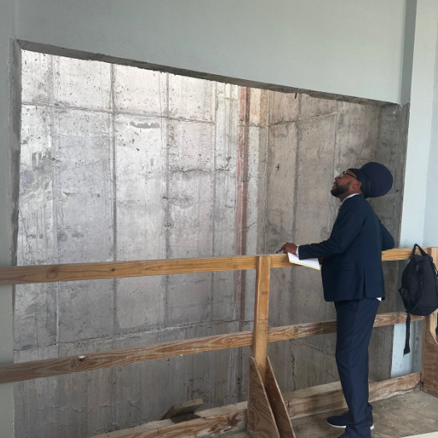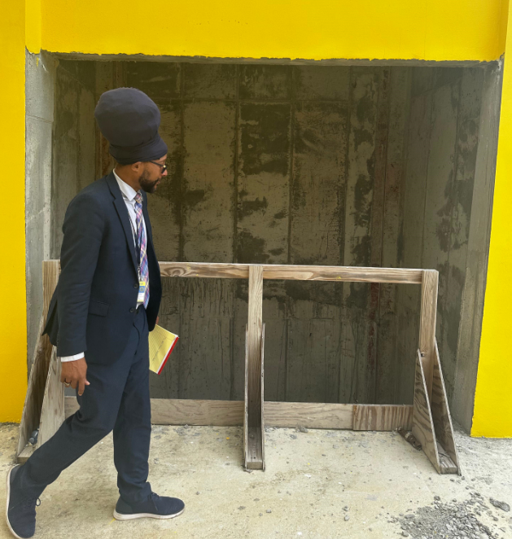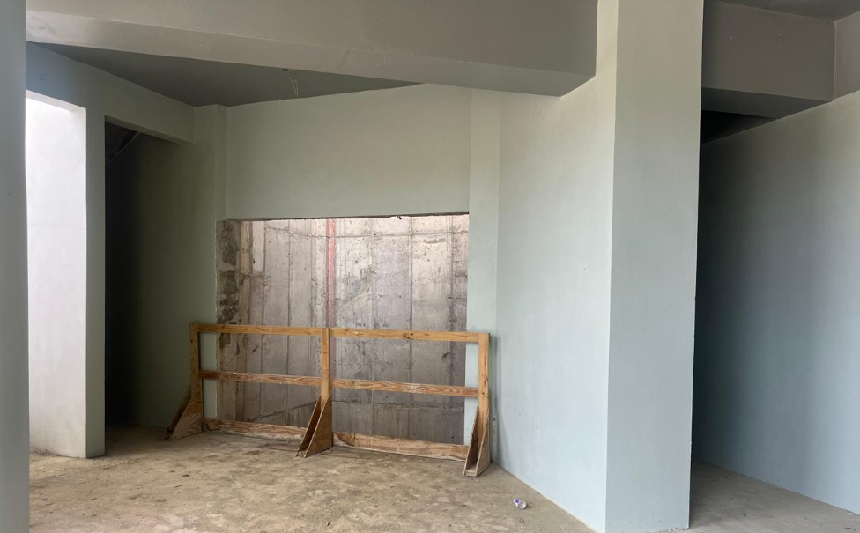

Appendix 12. Light Fixtures
Light fixtures were observed on the field only. No interior lighting was present in key areas such as:
- Corridors
- Stairwells
- Service rooms
- Locker rooms
- Restrooms
- Concession interiors
Photos confirm that these areas lacked lighting fixtures, conduit, wiring, or switchgear. There were also no visible mounts or junction boxes, indicating that electrical installation for interior lighting had not begun. This absence renders enclosed areas unsafe and non-operational, especially under low-light or nighttime conditions.
The current condition is not compatible with the claim of full lighting installation. If the reported cost includes only field lighting, this should have been itemized separately. There is no evidence of completed or in-progress lighting work in interior zones.
Conclusion:
The claim of 100% completion is inaccurate. While field lighting is in place, interior lighting infrastructure remains incomplete or absent. Based on inspection findings and the reported cost of $101,000, further clarification is required to explain what scope was included, how completion was determined, and whether the figure reflects only partial delivery.
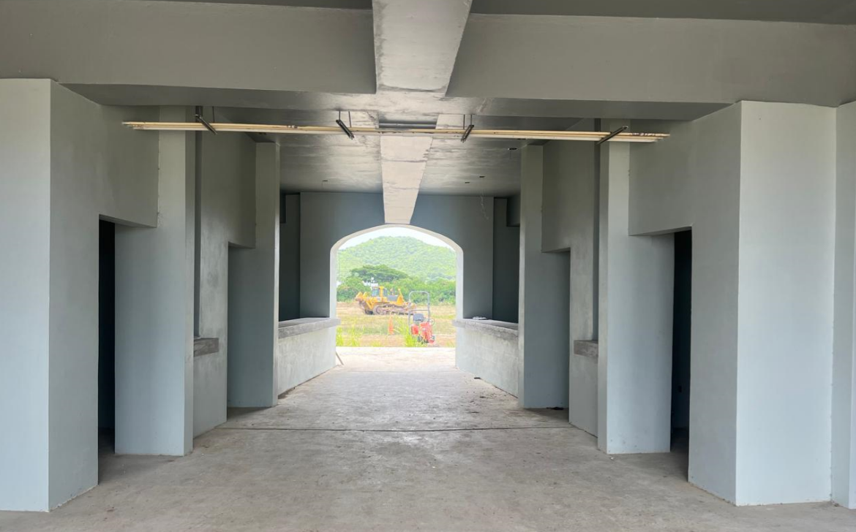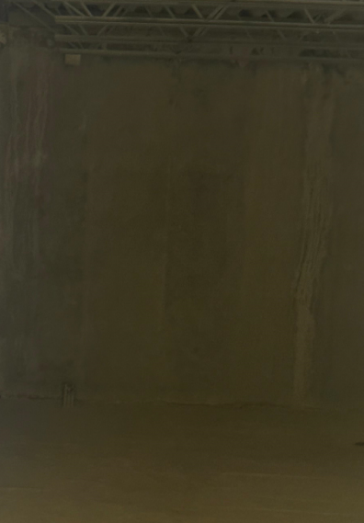
Appendix 13. Concession Areas
The concession structures are visibly in an early stage of construction and are not close to operational readiness. At the time of inspection, the following essential components were not present:
- No electrical breaker box, wiring, or conduit connections
- No plumbing lines, drain connections, or visible water supply points
- No sinks, basins, or sanitary fixtures
- No lighting fixtures or electrical terminations
- No countertop finishes suitable for food preparation or service
- No window security such as roll-up shutters or grills
- No epoxy flooring, tile, or other sanitary surface finishes
- No cabinetry, shelving, or built-in appliances
- No ventilation system or exhaust hoods
- No signs of fire suppression, alarms, or compliance measures related to public food service use
Conclusion:
The reported 50% completion significantly overstates the current condition. Based on the absence of utility infrastructure and fit-out components, actual completion is estimated to be less than 25%. Substantial additional work is required before these areas can meet health and safety regulations or be considered operational for concession use.
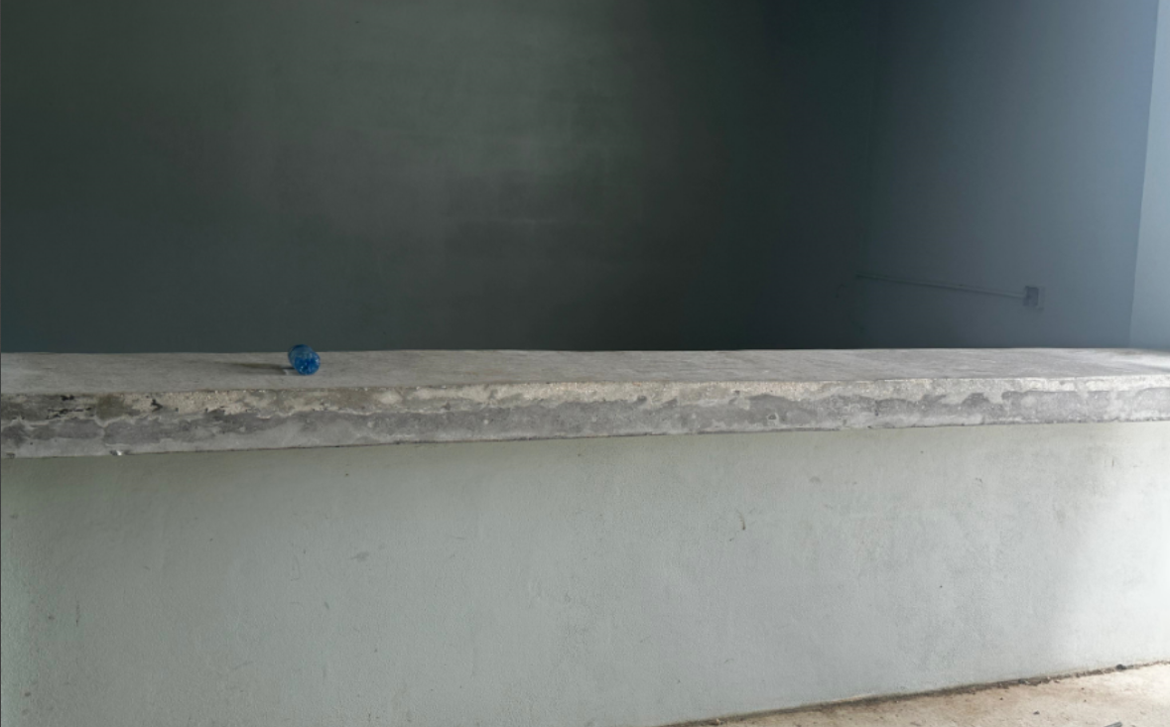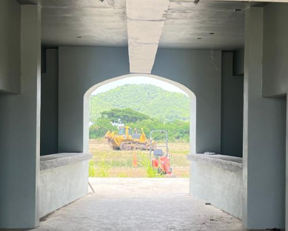

Appendix 14. Sitewide Observations
1. Inspection revealed water accumulation in an enclosed concrete area. The following conditions were observed:
- No floor drains or visible water removal systems
- Flat slab with no visible slope to direct water away from the space
- Water stains and mold-prone conditions, suggesting repeated exposure
- No waterproofing treatments or surface coatings visible
- Loose debris and material breakdown, indicating ongoing water damage
These issues pose safety hazards, promote deterioration, and highlight a lack of basic drainage planning.
Conclusion: This condition presents both functional and safety risks. Immediate corrective work is needed to install drainage or waterproofing systems in accordance with building codes.
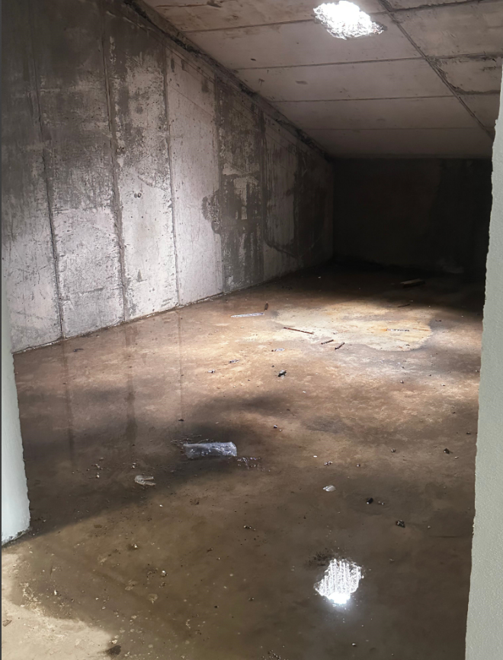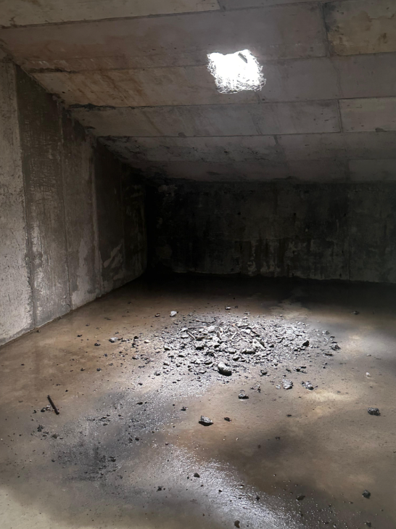

2. Unfinished Field Grading and Lack of Turf
Inspection of the main athletic field revealed that the area remains undeveloped and unsuitable for use. The following conditions were documented:
- No turf or seeding applied across the field surface
- No visible grading work to shape or level the playing area
- No drainage infrastructure observed, including swales, basins, or underground piping
- No irrigation systems or signs of trenching for water lines
- Exposed soil and patches of weed growth throughout the field
- Heavy equipment was present, indicating that work may still be in early stages
Conclusion: Based on current site conditions. Further clarification and a breakdown of the field work scope and progress are required.
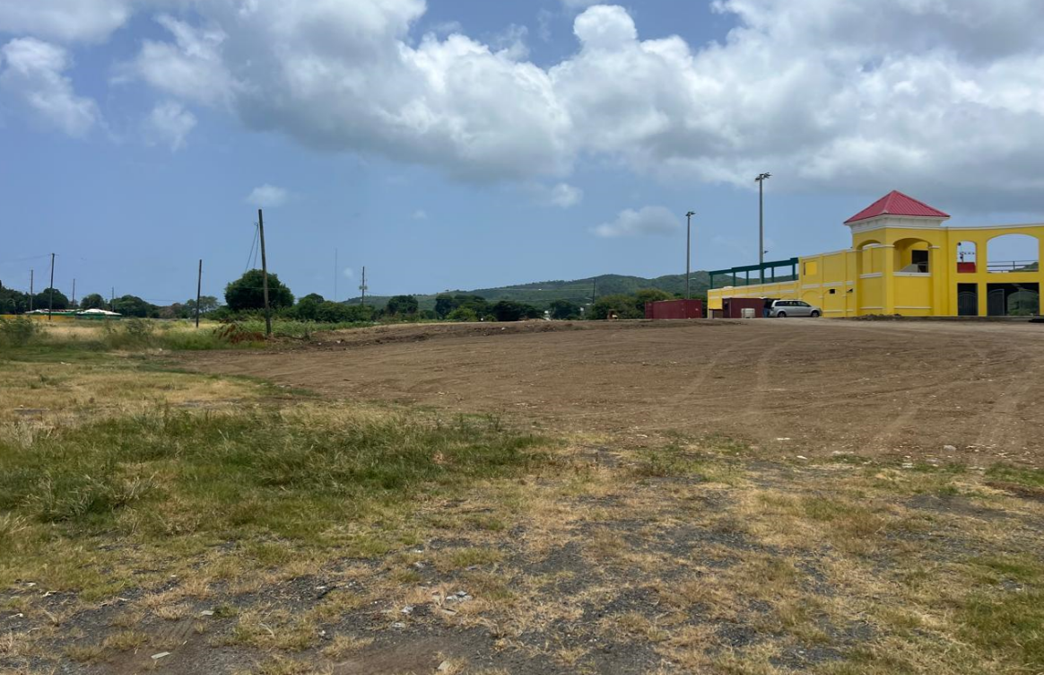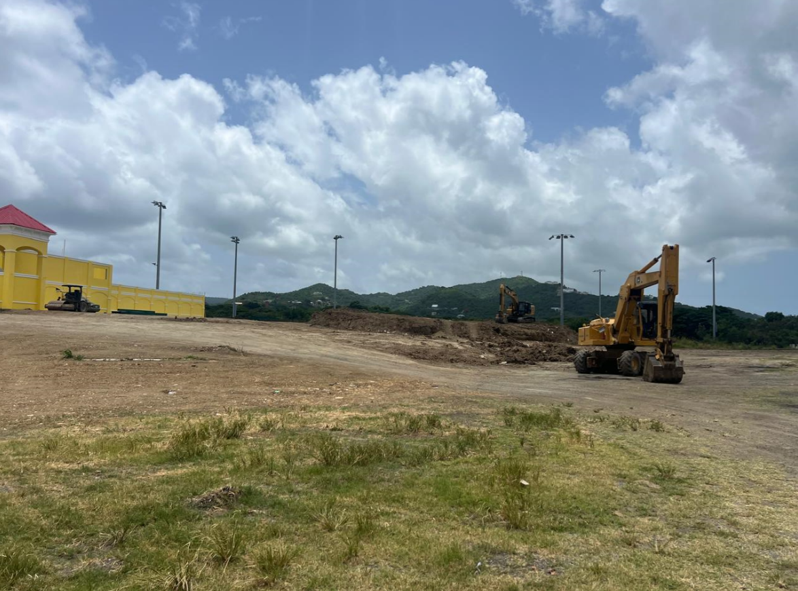

3. Incomplete Canopy Structure and Public Safety Features

Inspection revealed that the stadium’s spectator canopy. The overhead roof structure intended to protect attendees from sun and rain remains incomplete. While partial steel framing has been erected on one side of the seating area, the system lacks roof panels, purlins, weatherproofing materials, or any finished structural components. The installed framework also appears too short in span to adequately cover the seating area, leaving spectators vulnerable to sun and rain exposure even if completed.
The opposite side of the seating area has no visible canopy infrastructure, resulting in an inconsistent and inadequate approach to spectator shelter.
Additional issues observed:
- No roof panels or protective cladding installed.
- Insufficient canopy span on the west side to provide effective weather protection.
- No canopy structure at all on the east seating area.
- No handrails, barriers, or safety features along walkways or retaining wall edges.
- No public seating, guardrails, or edge protection installed in the bleacher zones.
These conditions raise serious concerns regarding public safety, weather protection, and readiness for spectator use. The incomplete and imbalanced canopy infrastructure does not align with best practices for spectator facilities.
Conclusion:
The canopy structure is both physically incomplete and dimensionally inadequate to fulfill its intended function. Without extended coverage and structural completion on both sides of the seating area, the facility does not meet basic operational or safety standards. Additional construction is clearly required before this area can be considered safe or functional for public events.
Left Side Right Side
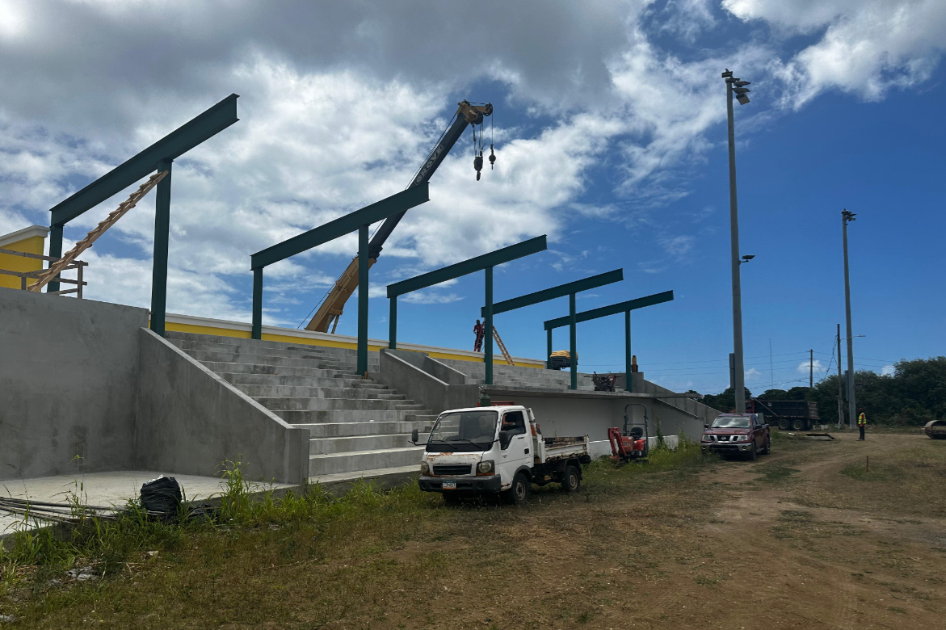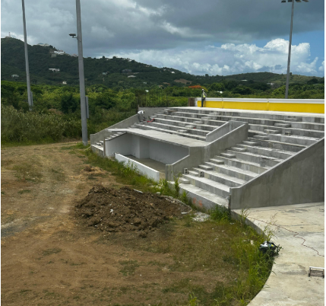

Notes on Progress Report Items Requiring Clarification:
Note 11(vi): Wall, Tile, Floor, Ceiling
Observation:
The project documentation lists “Concession Equipment” as an a la carte item under this category, specifically labelled as Item J. However, during the course of our review and document search, no reference or definition of “a la carte item J” were located.
Action Required:
Further clarification is needed from the contractor or project manager to determine:
- Whether Item J was included under a different designation
- What scope it covers (if any)
- Whether it affects Concession Equipment deliverables and installation

Note 18(v): Floor Finishes – Storage Closet Near Electrical Room
Observation:
The area referenced under Note 18(v) is described as a storage closet adjacent to the electrical room. However, during the July 1–2, 2025 on-site inspection, no such storage closet was identifiable in that location.
- The room immediately next to the electrical room contained standing water, as documented in the site photo with the visible puddle at the base.
- The space lacked clear signage, flooring, or configuration consistent with typical storage use.
Conclusion:
The room referenced does not appear to function as a storage closet. Its designation and intended use should be re-evaluated, especially considering drainage and water intrusion issues.

Unexplained Design Change Orders and Additional Design Costs
Observation:
The cost summary lists Design Changes CO 10 ($94,800), CO 11 ($95,200), and Additional Design Costs CO 13 ($612,500), totaling $802,500, all marked as 100% complete. However, no documentation was provided to explain the nature, scope, or justification for these expenses. There is also no indication of who approved these change orders or how the figures were determined.
There were no revised construction drawings, addenda, memos, or supplemental scopes of work included in the project file or on-site documentation. It is unclear what specific deliverables were provided in exchange for these costs, and no physical work linked to these change orders was identified.
Clarification Required:
Further explanation is needed from the contractor, project manager, or DPW representative to determine the following:
- What specific design changes were implemented under CO 10, CO 11, and CO 13
- Who authorized these changes and on what basis
- Whether supporting documentation (e.g., revised drawings, consultant reports, or scopes of work) exists
- Whether these design changes were competitively sourced or approved internally without oversight
- Whether any portion of this design work directly impacted the current state of construction or contributed to observed delays
Conclusion:
At this time, the design-related change orders appear unsupported and unverified. Given the high dollar amount, this item requires full documentation and cost reconciliation. The lack of accompanying justification raises concerns about the adequacy of oversight and the validity of these expenditures.

Reporting Requirements Under Act No. 8326
Observation:
Act No. 8326 requires the Department of Public Works to submit bi-monthly project reports to the Legislature that include the project timeline, updated photographs, detailed budget information, staffing reports, accounting records, and approved plans and permits for the Paul E. Joseph Stadium Project and related facilities.
Based on the May 31, 2025 progress report reviewed during the July 1 to 2, 2025 inspection, several design-related expenditures, specifically CO 10 ($94,800), CO 11 ($95,200), and CO 13 ($612,500), totaling $802,500, were listed as 100 percent complete. However, to our knowledge this specific report did not include documentation explaining the nature of these changes, who approved them, or what deliverables were associated with the costs.
Clarification:
It is unclear whether prior bi-monthly reports submitted to the Legislature contain the required details, approvals, and documentation related to these design change orders.
Recommendation:
To ensure compliance with Act No. 8326 and to maintain transparency around the use of public funds, it is recommended that the previously submitted reports be reviewed to determine whether the required documentation exists. A formal clarification should be requested from the Department of Public Works regarding the scope, approval process, and financial breakdown of these design changes. Future progress reports should include clear references to design changes, associated approvals, and their impact on overall project cost and schedule.

Executive Summary
This report presents the findings of an on-site inspection conducted on July 1 to 2, 2025, to evaluate the progress, quality, and financial integrity of the Paul E. Joseph Stadium construction project. While the project has advanced in select areas, the inspection revealed substantial discrepancies between the reported completion percentages and the actual physical conditions on the ground.
Most notably, the facility's elevator shaft essential for ADA accessibility and life-safety compliance remains entirely incomplete. There is no elevator cab, no mechanical components, and no electrical infrastructure in place, despite the report stating that this element is 92.3 percent complete. This is not a minor oversight; it reflects a profound disconnect between documented progress and lived reality, particularly for seniors, individuals with disabilities, and families who will rely on this facility.
Additional concerns include mechanical, electrical, and concession areas that are visibly underdeveloped or non-functional, yet are reported as largely complete. These visual inconsistencies call into question the accuracy of the progress report and the integrity of milestone-based payment approvals.
Even more concerning is the appearance of three substantial design-related change orders: CO 10, CO 11, and CO 13, totaling $802,500. These charges are marked as fully complete but are unsupported by any documentation in the May 31, 2025 progress report. There is no indication of who approved these changes, what the design deliverables entailed, or how the costs were validated. The absence of this information raises serious concerns regarding fiscal accountability and potential mismanagement of public funds.
Taken together, these findings reflect potential lapses in oversight, reporting compliance, and contractor accountability. Given the public investment in this long-delayed capital project, immediate clarification and documentation are not just recommended, they are essential. To protect public interest and fulfill the transparency requirements outlined in Act No. 8326, it is imperative that all unresolved items be addressed before any further approvals or funding considerations proceed.

