The 35th Legislature of the U.S. Virgin Islands
Committee on Homeland Security, Justice, and Public Safety

Bureau of Motor Vehicles Testimony on Bill 35-0046
Thursday June 22, 2023

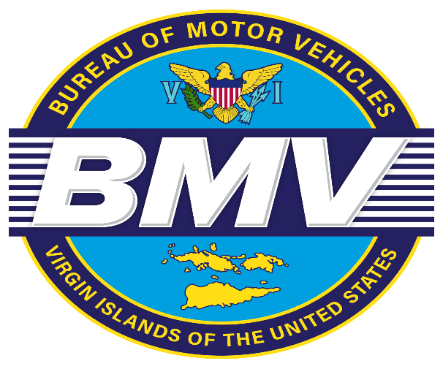

Barbara Jackson-McIntosh
Director
Bureau of Motor Vehicles

Presented by Leon Lafond
Assistant Director
Bureau of Motor Vehicles

Good morning Honorable Senator Kenneth L Gittens, Chairman of the Committee on Homeland Security, Justice and Public Safety, other members of the Committee, the listening and viewing audience. On behalf of Director Barbara McIntosh, I am Leon LaFond Assistant, Director of the Bureau of Motor Vehicles.

I am here today to provide testimony on Bill No. 35-0046, an Act amending title 20 Virgin Islands Code, part II, chapter 43 subchapter I to establish parking for expectant mothers and mothers with newborns. Again, we thank and applaud the bill sponsor Senator Franklin D. Johnson.

The Bureau of Motor Vehicles will honor and support the legislation of this bill.

Thank you.

