The 35th Legislature of the U.S. Virgin Islands

Committee on Homeland Security, Justice, and Public Safety

Bureau of Motor Vehicles Testimony on Bill 35-0035

Thursday June 22, 2023

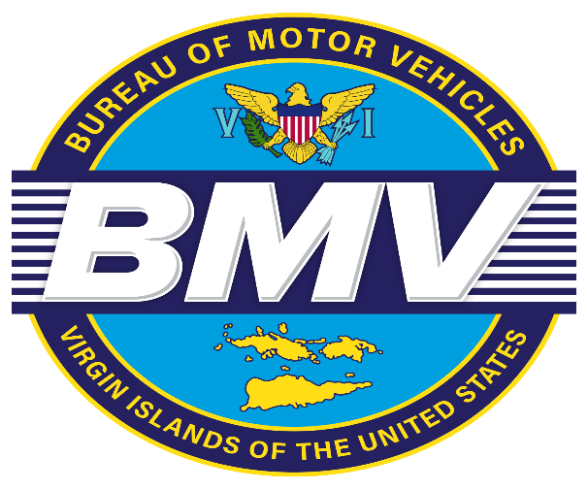

Barbara Jackson-McIntosh

Director

Bureau of Motor Vehicles

Presented by Leon Lafond

Assistant Director

Bureau of Motor Vehicles

Good morning Honorable Senator Kenneth L Gittens, Chairman of the Committee on Homeland Security, Justice and Public Safety, other members of the Committee, the listening and viewing audience. On behalf of Director Barbara McIntosh, I am Leon LaFond Assistant, Director of the Bureau of Motor Vehicles.

I am here today to provide testimony on Bill No. 35-0035, an Act amending title 20 Virgin Islands Code, part II, chapter 39 section 436 (b), that will expand the definition of “disabled veteran” for the purposes of eligibility for a handicapped window decal. We thank and applaud the bill sponsor Senator Franklin D. Johnson.

The Bureau of Motor Vehicles is in full support of this bill since it would also allow the Virgin Islands Office of Veterans Affairs the opportunity to issue license plates with the disabled veterans decal. Currently the Virgin Islands Code refers only to license plates with the disabled veterans decal issued by the United States Veterans Administration.

Once again, we thank Senator Johnson for spearheading this initiative and we look forward to continuously serving the people of the Virgin Islands as an agency that stands by our motto “Excellence is All We Do.”